Variability Activity
Keywords: grid sampling, variability, precision agriculture, zone sampling, soil type, hands-on activity, percentages

Purpose
This exercise showcases the concept of sampling and variability. Discussion can dive deeper into the importance of this type of sampling and the value it can provide.

Sampling=the act of taking observations

Materials Needed:
Grid Option A: Dimensions 8 feet by 8 feet
- Painter’s tape
- 49 cups
- Cards labeled 1-49 to place on the side of the cups
- Markers. I put two in each cup, but at a minimum need 49 markers-one for each cup. You will need four or five different colors. Example:
  - 7-10 red markers
  - 7-10 yellow markers
  - 7-10 green markers
  - 7-10 blue markers
  - 7-10 purple markers

Alternative Options:
- Use marbles, beans, or buttons and place them in containers with lids inside each square.
- Use a different-sized grid than 7x7 to allow for more samples collected or to cut down time on collecting samples.

NOTE: There are a variety of ways that you can create this grid and sample sheet. Be creative and use the resources you have! You can make smaller table-top grids, or larger ones for more room for movement. Always reach out if you have any questions.

Activity Class Time
Set up takes about 15 minutes
Lesson takes about 45 minutes utilizing introduction, activity, and take-home messages. This can be done as a stand-alone or as a supplement to Lesson 1 of the Precision Agriculture PowerPoints.

Set-up Before Class (15-20 minutes)
- Assemble your field boundary.
  - Mark an 7x7 feet square on the ground with Painter’s tape.
    - The grid can be made in smaller sizes and ratios. This allows more people to interact within the box.
- Make the grid.
  - Designate a “top” to your field. This will be referred to as north throughout the activity.
  - Evenly space six pieces of tape on the floor running north and south in the field to create strips.
  - Repeat Step 2b with six pieces running evenly east and west to form 49 squares in your field.
- Set out labeled cups
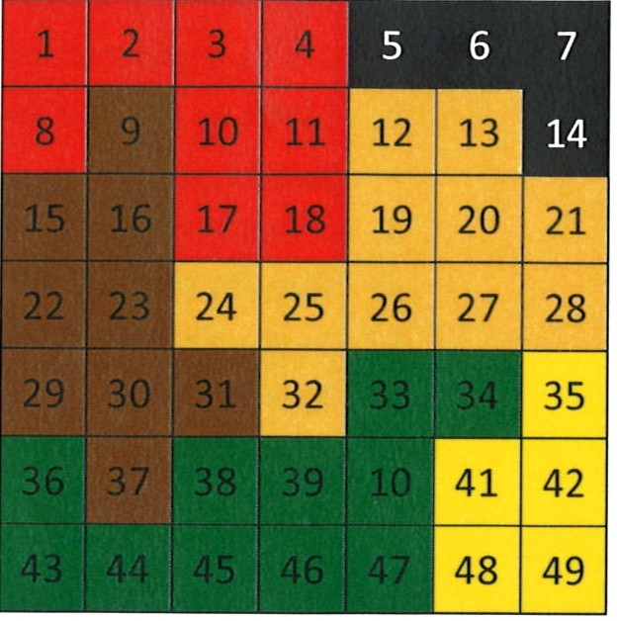
  - Ensure that you have labeled each cup with its appropriate ID. For this activity, our identification numbers will be 1-49.
Figure 1. Sample Grid
  - Place numbered cups in the grid. One cup will belong in each square created by the tape. Use Figure 1 to help you set the cups up in correct numerical order.
- Put data in each cup
  - Take your variety of markers and distribute them amongst the cups. I put two of the same color in each cup just so two people can be at a location as the same time.
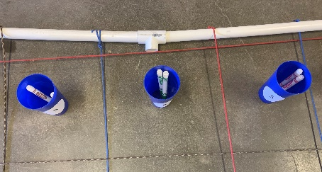
  - Put them in the cups lid down so they can’t see the color as easily. Figure 2 showcases this. If you are feeling fancy, you can make an intentional pattern. I place the markers in the cups randomly. You can use the Figure 1 help you get started, but it does not have to match this pattern every time.
- Get Sample ID data sheets printed.
  - These are available towards the end of this activity.
Figure 2. Example of markers cap down in the cups
- Set-up is complete when each cup has at least one marker in it, and you have the students’ data sheets printed.

Classroom Instructions
Materials Students Might Need:
- Clipboards, or something that they can write on when they are moving through this activity collecting samples

Introduction Talking Points (Spend about 10 minutes discussing these topics)
Introduce the topic by explaining the concept of sampling.
- Ask the kids if they know what sampling is, and what different kinds of sampling exists.
  - Sampling=taking observations about something
  - Soil sampling, tissue sampling, random sampling, grid, zone, to name a few.
  - Today we are going to demonstrate variability through grid sampling.
- Ask, “what is grid sampling?”
  - Grid sampling=soil sampling method in which a field is divided into square sections (grids) of equal size. Size of each grid is dependent on the grower and what their goals are. Samples are then taken from each grid.
  - UNL recommends a grid size of 1 acre. A general recommendation is grid size of no bigger than 2.5 acres. g1740.indd (unl.edu)
  - Full soil sampling should happen every 4-5 years. If you are working more intensely on improving soil health, it would be a good idea to have your soils tested more frequently than that.
  - In a real-world scenario, we would collect 10-15 soil samples, called cores, from each location on the grid. Today, we will be collecting one marker from each spot. We can assume this is the average of our 10-15 samples from that location.
  - The grid you have in front of the students represents a field. You can decide what each sample grid represents-I normally say 1-acre represents one square in our grid.
  - When you collect samples, you keep them organized by using Sample IDs. Today, our sample IDs are simply the numbers of 1-49. Growers can use any ID organizational method they want, as long as it makes sense to them.
- Your students are going to be soil samplers today. They are going to go to each place in the field, grab the marker out of the cup, and color the corresponding location on their data sheet. Color spot 1 on the sheet with the marker in cup 1 and so on and so forth.
  - Once they collect all 49, we will move on to the next step.

Activity (20 minutes)
Allow them to group up or individually work on collecting samples.

Post-Activity (15 minutes)
There are several different avenues you can take based on your age group and what you have already discussed in class. Feel free to wrap up the conversation however you see fit. Here are some ideas I have for you:
- When the students wrap up, ask them what they noticed about this activity. Ask them what these represent in the real world.
  - These points that we collected could be a variety of things. One thing that they could be in soil types. This can showcase the variability in a field. The take-home message is that with precision agriculture, we are looking for this type of variability and then we make more informed decisions based off the variability we see in our data.
  - You can discuss deeper the different soil types, and how they can be treated differently. One example is with variable-rate irrigation. This would allow us to irrigate the sandier parts of the field more frequently than the clay areas.
  - Doing forms of variable-rate application, whether it be irrigation, fertilizer, or planting, can allow us to save money in the long-run by not overusing products.
  - Have the kids go to Web Soil Survey and look up a field on their own farms or near your school. Have them find the sand, silt, and clay make-ups of each area of that field.
  - Discuss the differences between grid sampling and zone sampling.
    - Zone Sampling=areas of fields that have been recognized to have similarities, so they are put together into management zones.
      - Less samples can be taken in a field when compared to a grid sample as there might only be 4-8 management zones in a field. The exact number will vary, but they will generally be significantly less than the amount of grid samples that would be taken. It is still a good idea to periodically do the full grid sample as management zones may change over time. There are pros and cons of using each of these styles, and these few reasons are some of them.
    - You can watch this video to explain zone sampling versus grid sampling: Zone Sampling vs Grid Sampling - YouTube
  - Use math!
    - Have them calculate the percentage of each soil type (marker color) in their field. This should equal to 100, and that is how you can ensure that they did it right. If you used even numbers of each color of markers, then the percentages should be similar.
- Conclude by emphasizing that testing, including the grid sampling we did today, our soils reveals variability. Precision agriculture exists because of this variability and our effort to make sense of those differences that we see.
- Ideas on ways to alter this activity:
  - Have the students be split into groups and give each of them a different style of sampling. Example: split your field into management zones ahead of time. Have some groups do “zone” sampling, and some do grid. They can then do comparisons at the end to see our their data is similar or was skewed due to certain methods. They can do full-grid sampling, random sampling, or any method of sampling you can find online or in a statistics book.

1 | 2 | 3 | 4 | 5 | 6 | 7
8 | 9 | 10 | 11 | 12 | 13 | 14
15 | 16 | 17 | 18 | 19 | 20 | 21
22 | 23 | 24 | 25 | 26 | 27 | 28
29 | 30 | 31 | 32 | 33 | 34 | 35
36 | 37 | 38 | 39 | 40 | 41 | 42
43 | 44 | 45 | 46 | 47 | 48 | 49
Sample Sheet

What could the different colors in this map above represent? ______

__________________________________________________________

Why is variability important for people to understand? _____________

What decisions can you make from this data? ____________________

How often should you fully sample? _____________________________

1 | 2 | 3 | 4 | 5 | 6 | 7
8 | 9 | 10 | 11 | 12 | 13 | 14
15 | 16 | 17 | 18 | 19 | 20 | 21
22 | 23 | 24 | 25 | 26 | 27 | 28
29 | 30 | 31 | 32 | 33 | 34 | 35
36 | 37 | 38 | 39 | 40 | 41 | 42
43 | 44 | 45 | 46 | 47 | 48 | 49
Sample Sheet ANSWERS

What could the different colors in this map above represent? Soil type, electrical conductivity, vegetation index, moisture, yield, to name a few

Why is variability important for people to understand? It allows us to make more informed, intentional decisions. In the long run, it has the capability to save growers money and help protect the environment.

What decisions can you make from this data? The data we collected today can help us make irrigation application decisions (how much water, when?), variable-rate fertilizer recommendations, adjust our planting population, etc.

How often should you sample? At least every 4-5 years to get a complete picture

